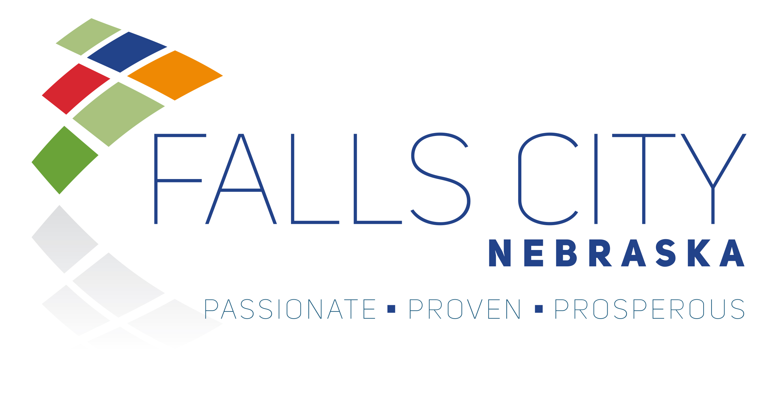

NOTICE OF SOLICITATION

MUNICIPAL SOLID WASTE COLLECTION, SPECIAL WASTE DISPOSAL, AND COMMUNITY CLEAN UP SERVICES

The City of Falls City, NE is accepting sealed proposals for Municipal Solid Waste Collection, Special Waste Disposal, and Community Clean up Services.

All proposals must be submitted in accordance with the Invitation for Bid (IFB). IFB documents are available at the City Clerk’s Office, 2307 Barada Street, Falls City, Nebraska, and online at www.fallscitynebraska.org/bid-postings

Sealed proposals must be received by 2:00 PM on April 6, 2026. The City reserves the right to reject any or all proposals and to award the contract in the best interest of the City.

If additional information is needed or if you have any questions, please contact:

Gary Jorn, City Administrator
2307 Barada Street
Falls City, NE 68355
g.jorn@fallscityne.us

