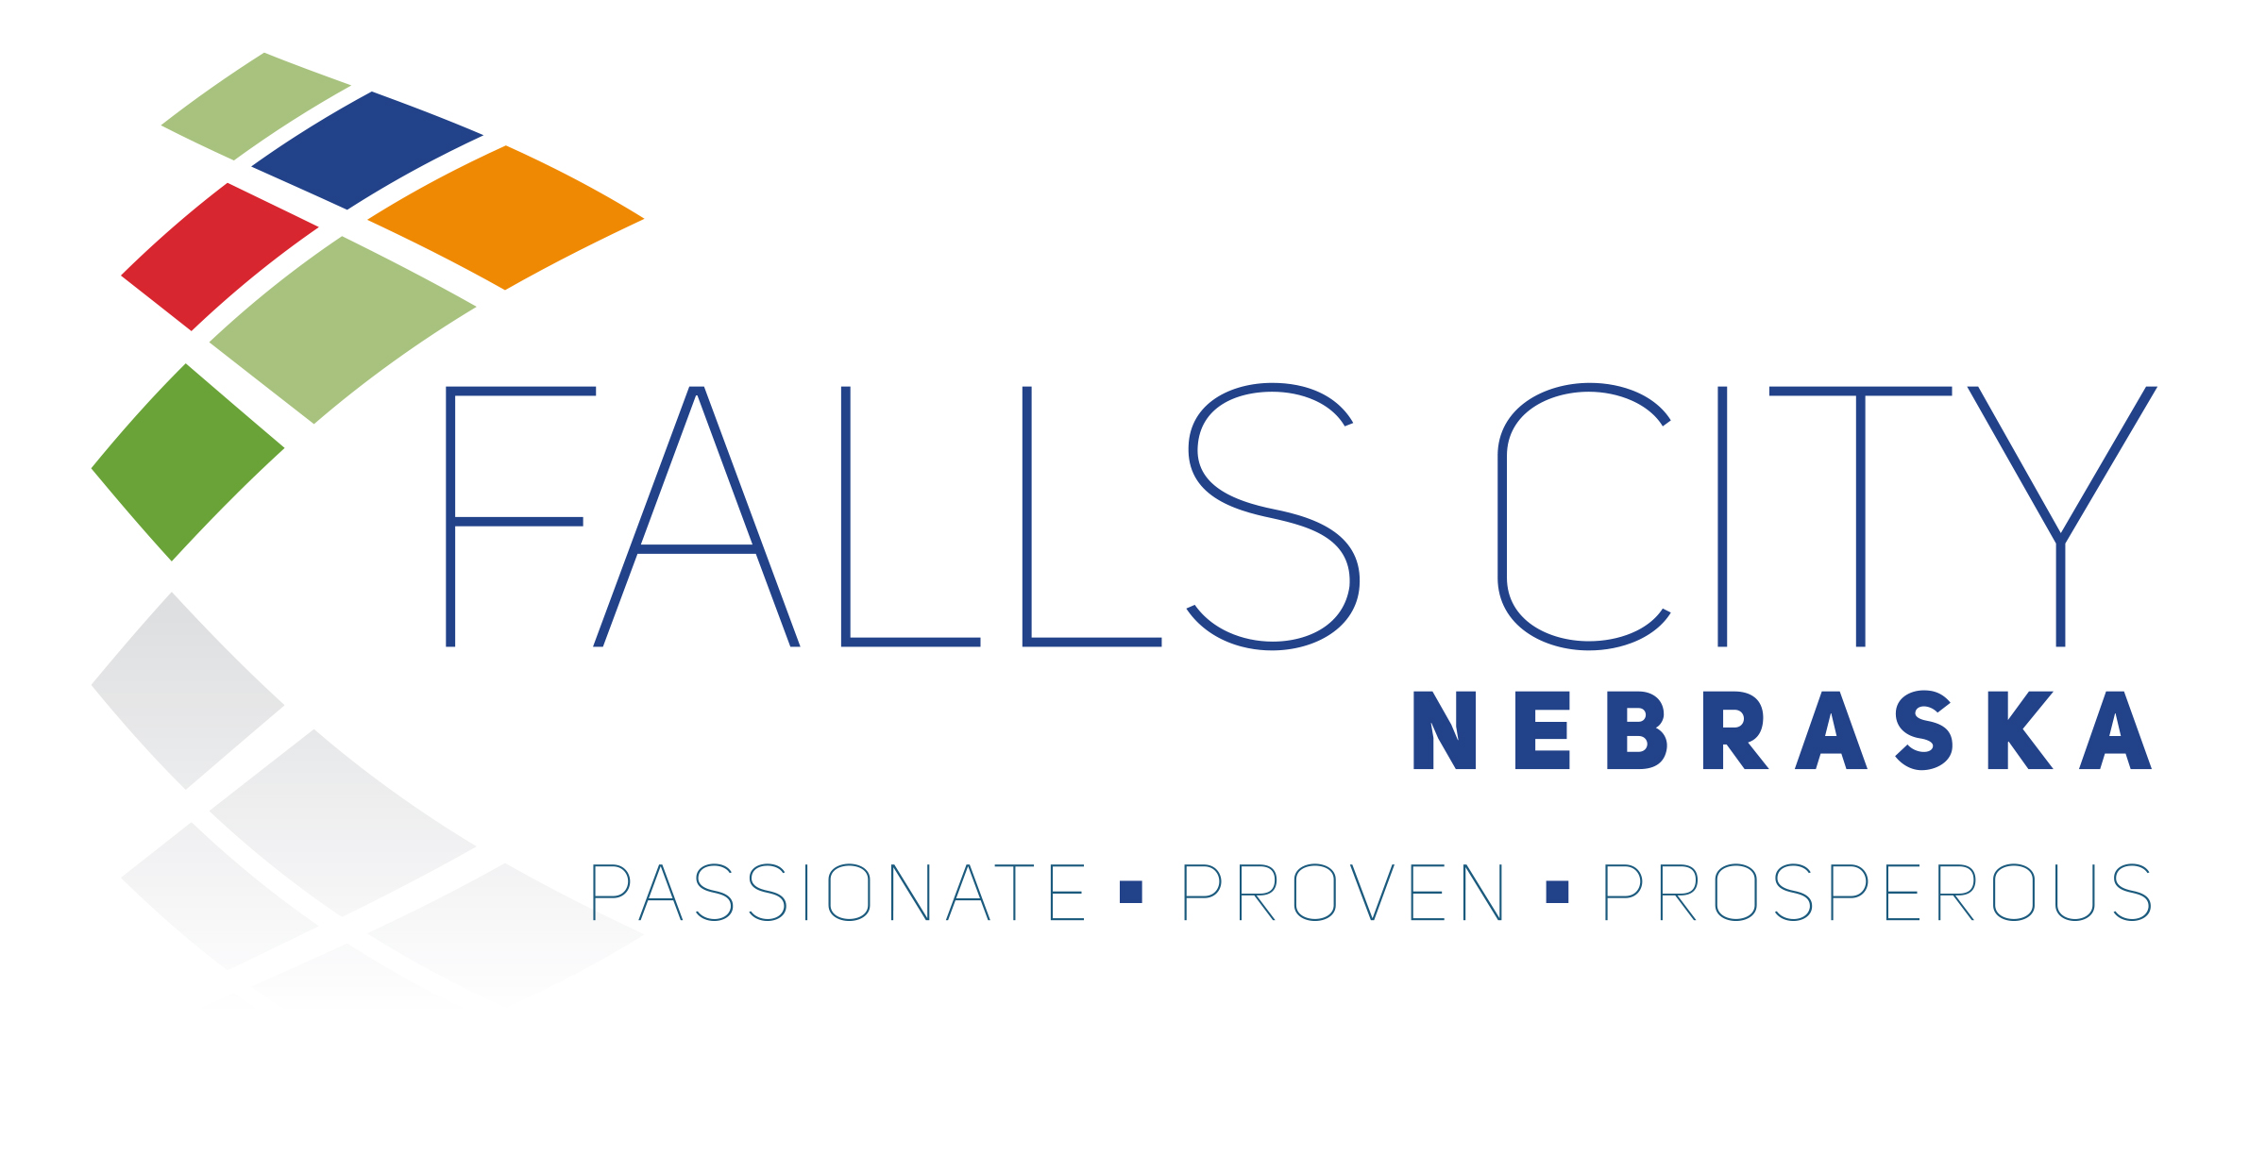

NOTICE OF SOLICITATION

PARKS & RECREATION – TREE REMOVAL, PRUNING, STUMP REMOVAL & TREE PLANTING

The City of Falls City, NE is accepting sealed proposals for tree removal, tree pruning, stump removal, and tree planting on public properties and rights-of-way throughout the City as part of the 2026–2027 Community Forest Improvement Project.

The project includes maintenance and removal of designated park and street trees, stump grinding, and the planting of approximately twenty-two (22) replacement trees at various municipal locations. The contract term is anticipated to run from April 13, 2026, through December 31, 2027, contingent upon grant funding.

All proposals must be submitted in accordance with the official Request for Proposals (RFP) documents. RFP documents are available at the City Clerk’s Office, 2307 Barada Street, Falls City, Nebraska, and online at www.fallscitynebraska.org/bid-postings

Sealed proposals must be received by 10:00 AM on April 3, 2026. Proposals will be evaluated based on experience and qualifications, project arborist credentials, project approach and methodology, schedule and capacity, and cost proposal. The City reserves the right to reject any or all proposals and to award the contract in the best interest of the City.

If additional information is needed or if you have any questions, please contact:

Briar Burr, Parks & Recreation Director
2307 Barada Street
Falls City, NE 68355
b.burr@fallscityne.us

