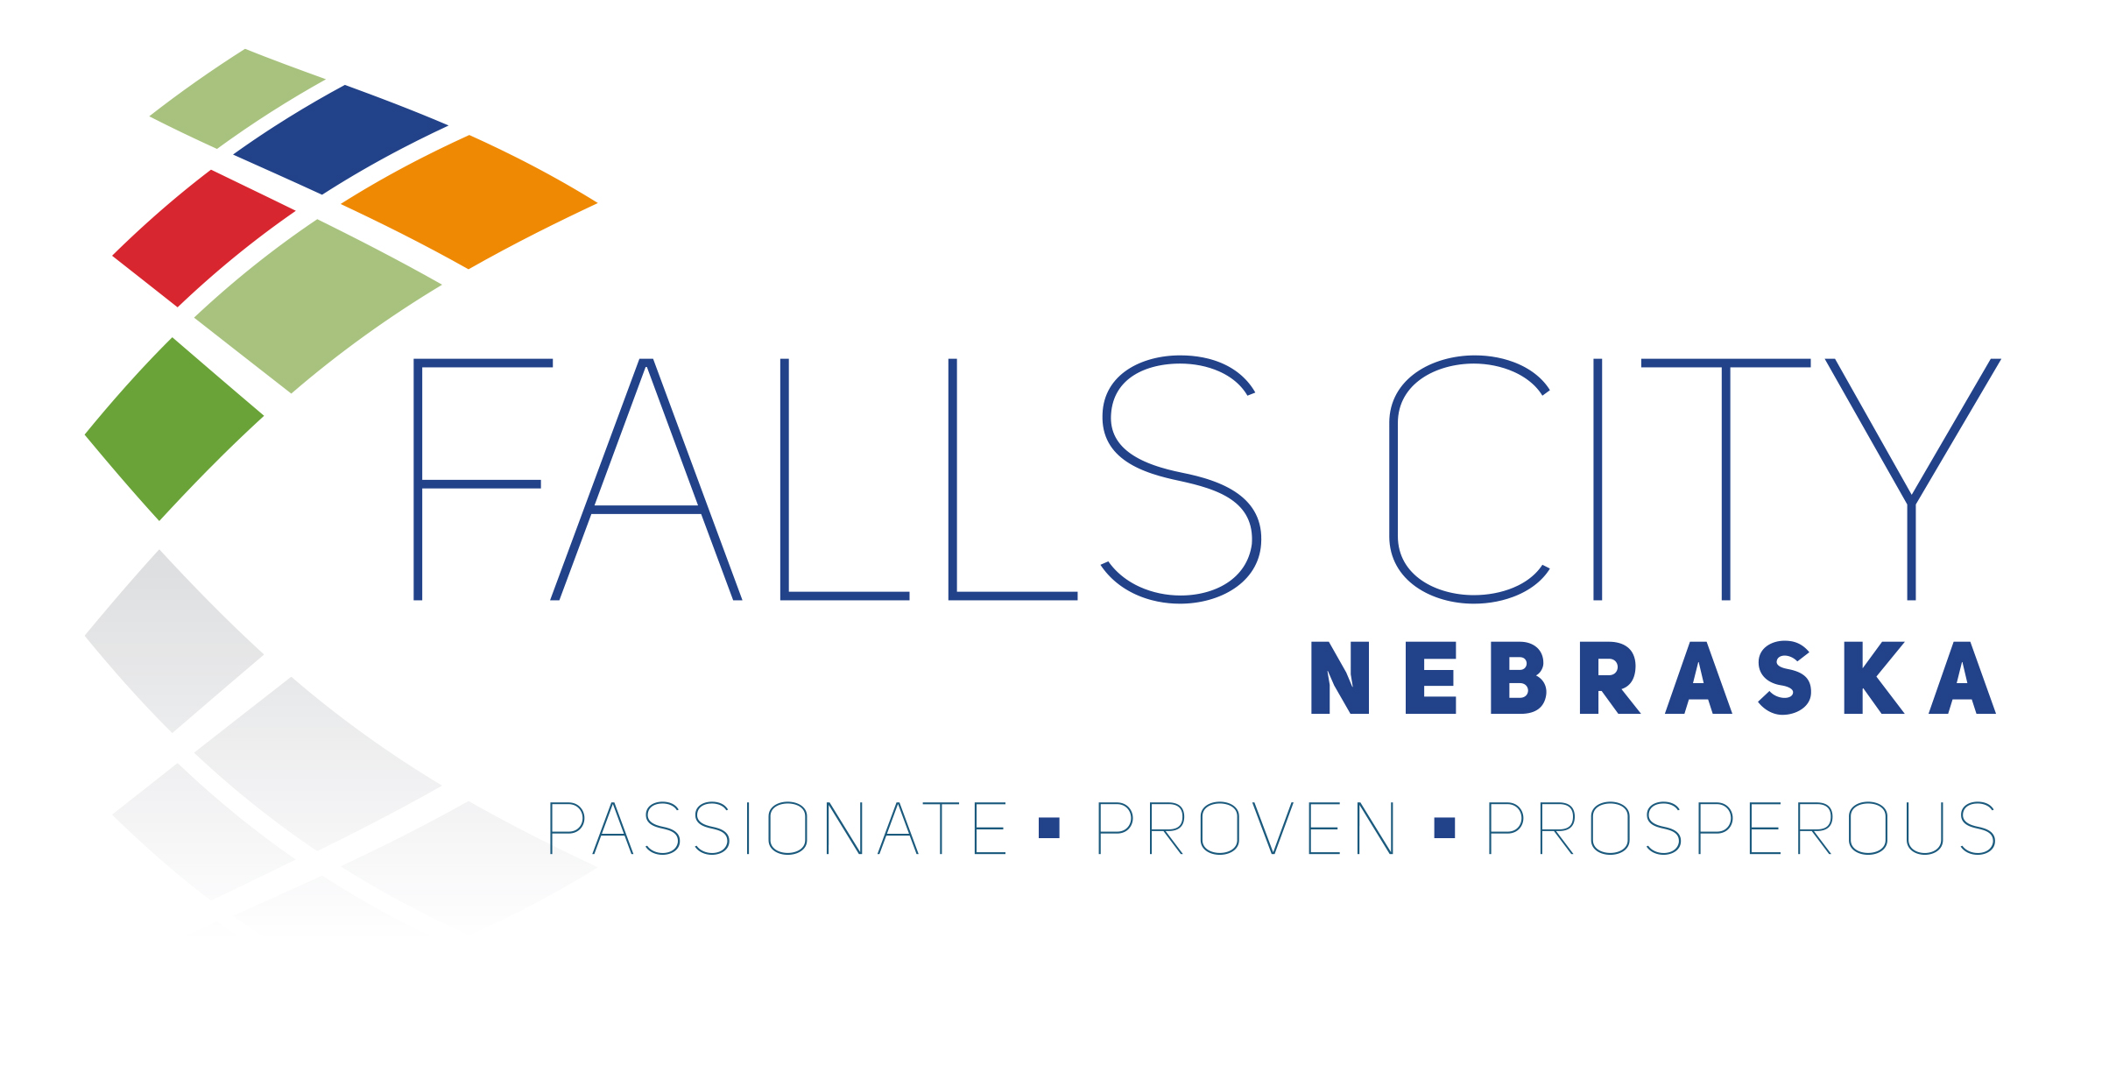

INVITATION FOR BIDS (IFB)

MUNICIPAL SOLID WASTE COLLECTION, SPECIAL WASTE DISPOSAL, AND COMMUNITY CLEAN-UP SERVICES

1. NOTICE OF SOLICITATION
Solicitation Release Date: March 4, 2026
Bid Due Date: April 6, 2026
Bid Due Time: 2:00 PM (Local Time)
Bid Opening Location:
City of Falls City
2307 Barada Street
Falls City, NE 68355

2. CONTRACT TERM
One year initial term beginning January 1, 2027 with two (2) optional one-year renewals, subject to annual appropriation.

3. SCOPE OF SERVICES
This solicitation is divided into the following phases:
• Phase A – General Municipal Refuse Collection (Single Lump Sum Bid Item)
• Phase A (Optional) – Rulo Water Treatment Plant
• Phase B – Wastewater Treatment Plant Special Waste Disposal
• Phase C – Community Clean-Up Event Services
You may bid on one or more phases.

PHASE A – GENERAL MUNICIPAL REFUSE COLLECTION
Power Plant – 901 S. Crook Street – 1 (1.5 CY) – Twice per week
Line Shop/Warehouse – South Crook Street – 2 (1.5 CY) – Twice per week
Street Department Shop – South Crook Street – 1 (1.5 CY) – Once per week
Stantons Lake Park – 2 (1.5 CY) – Twice per week (Apr–Sept); Once per week (Oct–Mar)
Library – 1400 Stone Street – 1 (1.5 CY) – Twice per week
Parks Shop – 903 S. Crook Street – 1 (1.5 CY) – Twice per week
Aquatic Center – 3002 Bill Schock Blvd – 1 (1.5 CY) – Twice per week (Apr–Aug)
Prichard Auditorium – 312 W. 17th Street – 2 (2 CY, City-Owned) – Minimum once per week

Optional – Rulo Water Treatment Plant
70434 661 Ave, Rulo, NE – 1 (1.5 CY) – Once per month

Phase A Bid Form
Base Monthly Lump Sum: $________________ per month
Optional Rulo WTP: $________________ per month

PHASE B – WASTEWATER TREATMENT PLANT SPECIAL WASTE DISPOSAL
Facility: Falls City Wastewater Treatment Facility, 2307 Barada Street, Falls City, NE 68355
Material: Washed, dewatered bagged screenings and washed, dewatered grit
Estimated Quantity: Approximately 40 tons annually
Current Service: Three (3) 4 CY dumpsters serviced every other Monday (7 AM – 4 PM)

Regulatory Requirements
Contractor must comply with KDHE Special Waste Authorization 24-0661 v2.0 and all landfill requirements.
Waste must pass EPA Method 9095 paint filter test (no free liquids).
Contractor must coordinate landfill approval and complete shipment records.

Phase B Bid Form
Transportation and Disposal: $________________ per ton
Minimum Haul Charge: $________________
Container Rental (if applicable): $________________ per month

PHASE C – COMMUNITY CLEAN-UP EVENTS
Two annual events (April and October) at Prichard Auditorium Parking Lot, 312 W. 17th Street.
Estimated 7–12 tons per event.
Contractor must provide containers, staffing, and proper disposal. No hazardous materials accepted.

Phase C Bid Form
All-Inclusive Price Per Event: $________________ per event
OR Roll-Off Rate: $________________ per container
Disposal Rate: $________________ per ton
Staffing Rate (if separate): $________________ per hour

4. GENERAL REQUIREMENTS
Contractor must be properly licensed and insured.
Missed collections must be remedied within 24-48 hours.
Renewal agreements may be offered for an additional 2 years

5. BID SUBMISSION REQUIREMENTS
Submit sealed bids clearly marked:
"Municipal Waste Services Bid – Due April 1, 2026"
City of Falls City, Attn: City Administrator
2307 Barada Street, Falls City, NE 68355

